HR COMMITTEE
DATE: | May 2021
TITLE OF REPORT: | HR Committee
AUTHOR AND CONTACT DETAILS | Gary McIntosh, Head of Human Resources gary.mcintosh@slc.ac.uk
PURPOSE: | Provide the HR Committee with a quarterly update on HR matters
KEY  RECOMMENDATIONS/ DECISIONS: | The Bo  1.  2. | ard is asked to:  Note the updates relating to staff.  Consider whether the bi-monthly staff newsletter should be circulated to the Board.
RISK | 1. | Impact of COVID-19 on the health and wellbeing of employees.
 | 2. | Business, employee and student impact of long term and/or frequent absence.
RELEVANT STRATEGIC  AIM: | Successful Students  Highest Quality Education & Support Sustainable Behaviours
SUMMARY OF REPORT: | The report will provide insight into each of the following areas:  - Headcount Management including absences.  - Health & Wellbeing including the enablement of key people being to handle mental health situations through the targeted approach to Mental Health First Aid Training.  - Employee Engagement including: the review of processes supporting the employee journey, followed by redesign and automation, where appropriate; and the continued improvement to employee communications.  - Learning & Development.  - Performance.  - Employee & Industrial Relations.  - Maintenance of Accreditations including the requirements to: develop and automate Career Review; implement a Recognition Program and Succession Planning for management and critical roles.
Link to Fortnightly Staff Update | http://x84hx.mjt.lu/nl2/x84hx/x1oq.html?hl=en

1. INTRODUCTION

1.1 This paper provides an overview of HR matters for South Lanarkshire College for the period of 1st January to 31st March.

2. HEADCOUNT MANAGEMENT

2.1 The quarterly headcount movement is shown in the graph below, which demonstrates a slight movement in headcount over the quarter, with 6 3rd party contractors, 6 new hires and 8 leavers.

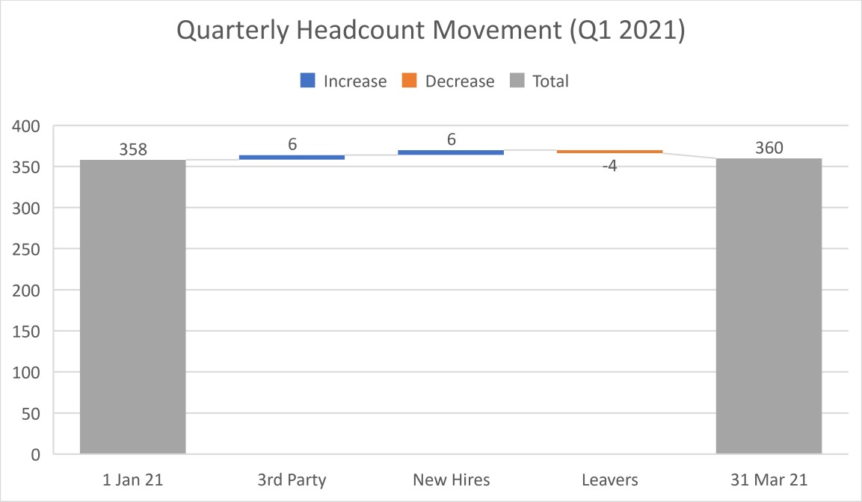
Note: Headcount as at 01.01.21 reconciled from previous quarter to be 358.

The following graph shows a comparison to the prior year, which is similar but with a higher number of new hires.

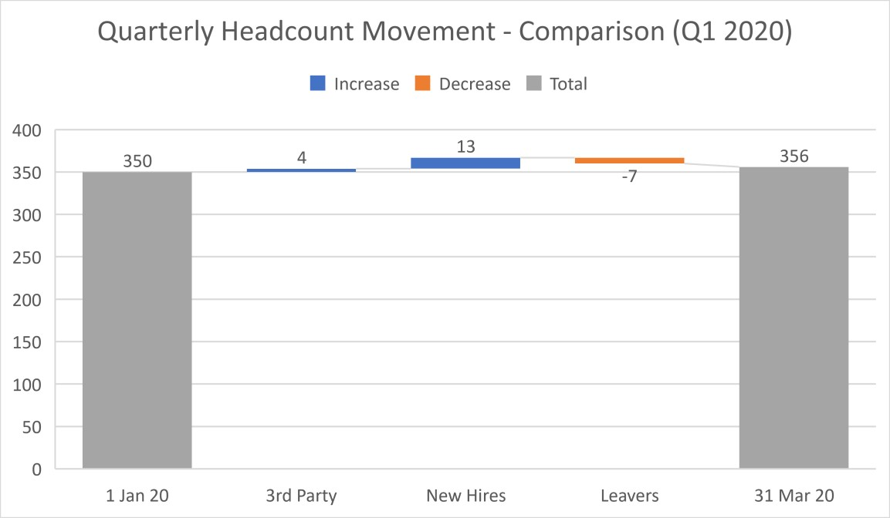

2.2 A list of new hires are included in Appendix A – not for publishin

2.3 Recruitment

Recruitment activities during the quarter are shown below:

Position | Reason | Status 23rd April
Associate Principal, Construction & Built Environment | Replacement | Interview Date 23.04.21Offer Stage
Lecturer – Plumbing & Gas (3 FTE) | Replacement | Shortlisting
Schools Co-ordinator | New Post | Interview Date 29.04.21
Lecturer – Counselling (Maternity Cover) 0.6 FTE | Maternity Cover | Interview Date 06.05.21
Interim Clerk to the Board, Principalship | Absence cover | Filled
Lecturer - Supported Programmes (0.4fte Perm), Faculty of Business | Replacement | Filled
Support for Learning Assistant (1 day per week, Term-Time), Faculty of Business | Replacement | Filled
Interim PA to Principal, Principalship | Absence cover | Filled
Lecturer – Police Studies  (Permanent, 0.5FTE), Faculty of  Business | Additional Headcount | Filled

2.4 Leavers ( not for publishing)

2.5 Absence (not for publishing)

3. HEALTH & WELLBEING

COVID-19 and mental health initiatives continue to be at the forefront of our Health, Safety & Wellbeing efforts.

3.1 COVID-19

The prolonged high tiers and lockdown situation, coupled with the impact of related matters including home-schooling, caring responsibilities, shielding, blended learning and subsequent lack of face-to-face & physical activity has significantly impacted the wellbeing of our employees and students. We have enhanced communications with our students and Student Association, employees, trade union representatives and leadership to ensure we are hearing views from right across the College, as well as engaging with peers in other Colleges and in the wider College community. Support staff on campus have been significantly reduced, whilst maintaining sufficient employees across Facilities to manage and ensure the sanitization of the building. Lecturing staff on campus are driven by onsite student numbers, therefore currently very low.

We continue to follow our protocol agreed with NHS Lanarkshire as required and to submit our weekly COVID-19 statistics to the Scottish Government. We also promptly responded to a false press article about a COVID outbreak on campus by issuing a corrective response, working with the publication to accurately update the story and by communicating swiftly with students and employees.

The College issued an updated COVID-19 Health & Wellbeing guide, revitalizing our benefits for colleagues to support themselves during the pandemic. The benefits continue to be popular and beneficial and include TogetherAll, PAM Assist (our Employee Assistant Program) and a range of engaging activities to maintain a degree of connectedness or support wellbeing. In addition, The College Leadership Team continue to review the situation, discuss issues for employees and seek to deliver tailored solutions.

3.2 Mental Health

Mental Health Working Group

The Group continues to meet on a regular basis to review and offer solutions for identified mental health challenges across the College. The last meeting was on 17th March 2021 and primarily focussed on the mental wellbeing of employees and students as a result of COVID19.

The Group is currently utilising social media platforms to signpost in house support services to students and staff, and to share information on mental health awareness campaigns.

Mental Health First Aiders

The number of Mental Health First Aiders currently stands at 6. A proposal to increase this by an additional 30 in response to College commitments to increase mental health support for students and staff is currently under consideration. Our ambition is to deliver courses by our internally trained Mental Health First Aid instructors to staff identified from core areas and key roles of support.

Guidance and support procedures for trained staff are being developed in collaboration with Kirsteen Newman, Curriculum Manager of Health and Social Care. Processes include supervision, support forums and reporting to capture intervention frequencies.

HSE Organisational Stress Risk Assessment

The College has appointed a partner to run a survey in support of this Organisational Stress Risk Assessment that will both ensure the anonymity when completing the survey and also allow for anonymous interaction should the College wish to gather additional insights from comments made. This work is supported by members of a Short Life Working Group, made up of a cross-section of college staff and supported by Trade Union colleagues.

4. EMPLOYEE ENGAGEMENT

The College is about to embark on an optimization of our approach to employee engagement. The approach to date appears to have been inconsistent and would benefit from a planned, data-driven approach.

4.1 Employee Journey & Experience

A process has commenced to review the employee journey from recruitment & onboarding, through to training & engagement and on to offboarding & alumni. The focus will look at both process optimization and experience for the employee, manager, leadership & HR.

An initial inside-out review of the employee journey from the HR Team concluded that there are improvement opportunities at each stage of the employee journey.

A review of the Capability and the Experience during each stage of the employee journey resulted in the following: (not for publishing)

 | Attract | Hire | Onboard | Engage | Perform | Develop
Capability
Team (Current)
Team (New Tasks)
Process
System
Experience
Employee
HR
Manager
Principalship

Key:
Good
Development

This exercise still needs to be completed for the offboarding and alumni stages.

As can be seen above, there is an opportunity to improve the capability and the experience levels across the employee journey. Moving forward, the approach is to review the current process and redesign these, with experience being considered when designing the new processes. System and automation will then be considered once the new process are designed, along with training and development for our new approach.

4.2 Employee Engagement & Internal Communications

A planned, optimised approach to employee engagement and internal communications will be created and implemented. HR and Marketing will be working closely to ensure this is implemented effectively.

Currently, we are trialling a fortnightly update is issued to all employees, summarising the messages of the College in bite-size sections (attached version w/c3 May). It may be useful to circulate this to Board members as a means of remaining connected to the College whilst we remain in a blended and remote mode of operation. Separately, we have also reviewed Facebook Workplace and are now exploring Microsoft Teams to improve our communication and engagement approach.

4.3 Equality, Diversity & Inclusion

The Equality Group met on Wednesday 13th January, when a number of items were actioned and discussed. A key focus of the meeting was to review progress of Equality Outcomes and the Equality Mainstreaming Report, due to be published by April 30th, 2021.

Equality Act – Public Sector Equality Duty
We have an obligation to take actions to meet the specific duties of the Public Sector
Equality Duty (PSED). The College had a higher than recommended number of Equality Outcomes for the period 2017 – 2021 and has achieved most of them, except for marketing material to encourage the disclosure of personal characteristics. The Outcomes and Themes are shown in Appendix C.

Gender Pay Gap Report
Women continue to be approximately 2/3 of the headcount in the College. The gender pay gap is continuing to narrow between male and female colleagues based on mean and median averages. The gap is driven predominantly by gender segregation in certain roles.

Difference between men and women | Mean (Average) | Median (Middle)
Gender Pay Gap 2021 | 9.48 % | 9.65 %
Gender Pay Gap 2019 | 13.24 % | 6.04 %
Gender Pay Gap 2017 | 16.67 % | 27.63 %

The spread (shown below) across the salary quartiles shows there is no glass ceiling for women. There are a large proportion of lecturers on the same salary pay point which skews the numbers across Lower and Upper middle quartiles, however there is no gender bias in these categories. The number of women at the lower end of the salary scale is what continues to reduce the mean and median figures for female colleagues versus male counterparts.

Lower Quartile

(
)
lowest paid

Lower Middle
Quartile

Upper Middle
Quartile

Upper Quartile

)
highest paid
(

22
%
78
%
Male
Female
31
%
%
69
Male
Female
68
%
%
32
Male
Female
%
11
89
%
Male
Female

5. LEARNING & DEVELOPMENT

5.1 The following graph show the current learning & development activities across the College.

Staff Training Programmes
18
14
12
10 8
6
4
2
0
 | Onboardi |  | ng | CMI Manage Developm |  | ment ent | First Aid |  |  | Social Media  Training - Student Association
In Progress | 9 |  |  | 8 |  |  | 8 |  |  | 0
Complete | 6 |  |  | 8 |  |  | 2 |  |  | 4
16
Number of Employees
Complete In Progress
5.2 The following graph shows the current Professional Development activities across the College. A brief explanation of each qualification is noted below:

TQFE – The Teaching Qualification in Further Education is the recognised in-service teaching qualification for FE lecturers in Scotland. The qualification is completed at Degree (SCQF 9) or Postgraduate (SCQF 11) level.

Professional Development Award (PDA) Teaching in Scotland’s Colleges – Qualification at SCQF level 9 intended for college lecturers who have subject specific expertise but no formal teaching qualifications. The PDA is used to prepare staff for progression to the TQFE.

Assessor and Verifier Awards – Qualifications for assessors and verifiers of regulated, taught qualifications. Ensures consistency in application of quality assurance and that occupational competence requirements of lecturers are met.

TQFE
PDA Teaching in Scotland's
Colleges
Assessor and Verifier
Awards
In Progress
8
1
18
Complete
0
8
4
0
5
10
15
20
25
Number of Employees
Professional Development
Complete
In Progress

5.1 The following graph shows the completion rates of the newly launched mandatory Corporate Parenting E-Learning training. Completion rate of 90% expected by June 2021.

33
%
67
%
New Mandatory Corporate Parenting E
-
Learning
Complete
In Progress

5.2 Staff Development Day

In response to the hard work and continuous effort needed to support delivery of our services in recent months, we encouraged staff to be flexible and prioritise time available on staff development day to maximise the value of the day for them including a focus on their own wellbeing.

A total of 15 staff development sessions were delivered on Friday 5th March with 156 staff members making up 210 bookings. The sessions were delivered as our 6th virtual staff development day and focused on learning and teaching, effective communication, supporting wellbeing and showcasing the talent of our own staff.

Our opening session ‘Your Questions Answered’ was a discussion with Principal, Aileen McKechnie and Marketing and Communications Manager, Scott Coutts. The session provided a platform for the Principal to respond to questions submitted by our colleagues. A further 186 members of staff attended live.

The following table shows the number of employees who participated in each course and the average satisfaction scores. The next staff development day takes place on Wednesday 16th of June.

Staff Development Day – 5th March 2021
Course | No. Employees | Satisfaction (out of 4)
‘Your Questions Answered’ Live Discussion | 186 | 3.4
Meeting Family Needs During the Pandemic | 19 | 3.2
First Aid for Mental Health Awareness Course | 10 | 3.5
Course Costing | 10 | 3.5
Bringing the Fun Back into the Virtual Classroom | 25 | 3.5
Time Management and Productivity | 25 | 3.4
Coping with COVID – Managing Stress and Developing Resilience | 19 | 3.7
Learn about Learning Development | 8 | 3.8
New Timesheets Demonstration (2x sessions - Management and Admin and Teaching Staff) | 11 | 3.9
Creating Inspiring Lessons for Virtual Learning | 13 | 3.7
Dine with the Devenny’s - Virtual Cook Along | 35 | 3.6
Confident and Effective Communication in the Workplace | 22 | 3.2
Virtual make-up session: From day to evening | 13 | 3.4
TOTAL | 396

6. PERFORMANCE

It is essential to ensure the College continues to be strategically aligned with
performance. Two areas of development for this are through team development with the College Leadership Team and also through Career Review conversations with all employees.

6.1 College Leadership Team – Team Development

The College Leadership Team has agreed a desire to progress a new approach to team development, to enhance our ability to operate successfully as one team. A survey has been completed, which has identified areas for consideration, including trust, transparency and managing conflict. The survey results are currently being analysed before progressing the development as a team. We will also use the information provided to identify areas of individual development, where participants have identified themselves.

6.2 Career Review

The Career Review process is currently being developed, in line with feedback from
Investors in People, to include reference to strategic priorities and also the values of the College. Once complete, this will be automated to improve the document management of the process.

7. EMPLOYEE & INDUSTRIAL RELATIONS

7.1 Contracts of Employment and Job Descriptions
Contracts of Employment and job descriptions for College Management and Lecturers are currently being reviewed. The JNC is involved in these discussion as follows:

- Assistant Principals: revised Contracts are under discussion with the APs with changes primarily being to extend the notice period to three months either side. Their job descriptions are also being updated to bring them in line with College requirements.

- Curriculum Managers: as a result of national bargaining, CMs are now deemed ‘promoted lecturer level 3’ and have had a salary increase to reflect this. APs are currently reviewing the CM job descriptions in line with the NJNC national agreement. The revised contracts of employment for this cohort are being prepared for issue by the end of April 2021. It is recognised that additional support and training may be required to support delivery of new tasks.

- Lecturers: Revised Contracts are being prepared following national bargaining agreements. All contracts have now been issued for Permanent Lecturers. Temporary Lecturer contracts are pending a clarification with the trade union. The revised contracts of employment for this cohort are being planned for issue by the end of May 2021.

- Deputy Head of Faculty: (3 staff) - job descriptions and contracts being prepared. The revised contracts of employment for this cohort are being prepared for issue by the end of June 2021.

- Heads of Department: job roles were previously evaluated and further work is required to review salaries and to update Contracts to reflect three months notice period. The revised contracts of employment for this cohort are being prepared for issue by the end of May 2021.

7.2 Employee Relations

EMPLOYEE RELATIONS ACTIVITIES
1
0
 | Q1 2021 |  |  |  | Q2 2021 | Q3 2021 | Q4 2021
Grievance | 1
Disciplinary | 1
Capability | 0
Other | 1
Grievance Disciplinary Capability Other 2
NUMBER OF CASES

7.2 National Issues

The support staff settlement for 2020/21 has now been concluded and the confirmation received from Colleges Scotland. This should be available within the May pay run.

We have submitted our response to clarifications for stage two of the job evaluation process for support staff. Heads of Service are also now being considered as part of this process.

The industrial relations dispute with EIS-FELA has now been suspended, given agreement reached on the wording of a job role descriptor for the lecturer position.

7.3 Review of HR Policies & Procedures

The HR Policy & Procedure Review process remains in train, commencing with the prioritised documents shown below, along with their status.

Document | Review Status
Code of Practice for Employee Competence | Being replaced with an Employee Capability procedure – draft is currently being reviewed with JNC
Grievance Policy & Procedure | Being updated, in accordance with ACAS guidelines
Disciplinary Policy & Procedure | Being updated, in accordance with ACAS guidelines
Dignity at Work | Not yet started
Code of Practice on Whistleblowing | Not yet started
Managers’ Charter | Not yet started

Colleges Scotland are also reviewing a higher-level agreement for the Grievance & Disciplinary policies, which ours will continue to be aligned with.

8.0 Maintenance of Accreditations

Maintenance of all three accreditations identified the following key actions, which are:
- Alignment of Career Review process with strategic priorities and values.
- Automation of Career Review process.
- Create and implement a College-wide recognition program.
- College-wide succession planning focussed on all people manager and critical roles.

Detailed of the prior recommendation for each accreditation is shown below.

Investors in People
Investors in People is due for renewal in December 2021. We have commenced discussions and planning with Mary Leishman, our new Account Manager from Re:markable, to progress our renewal.

Recommended actions from the previous award in 2019 are:

- Align management charter with changes in leadership role
- Define behaviours associated with values more explicitly
- Align the values, behaviours and management standards more formally
- Ensure consistency of managers’ capabilities in agreeing challenging and motivational objectives, providing feedback and recognising high performance as part of Career Review process
- Link personal objectives to team and College objectives.
- Consider methods of reward and recognition for high performance.
- Stronger focus on continuous improvement by leveraging feedback from students and staff
- Develop a formal succession plan to recognise high performers.

One early action is the automation of our Career Review process, which has been manual, hard to access and hard to report on.

Investors in People Health and Wellbeing
Investors in People Health and Wellbeing Award is also due for renewal in May 2022. We will assess our progress towards this as part of our overall Accreditations renewal action plan. Recommended actions from the previous award in 2019 are:

- Raise greater awareness of how the values and the Management Charter drive the development of a healthy working environment.
- Line managers to more visibly support physical, psychological and social health and wellbeing.
- Promote the successes and recognise the less effective activities in relation to health and wellbeing.
- Consider competitive challenges that encourage participation and engagement.

Leaders in Diversity
Leaders in Diversity renewal has been delayed due to COVID-19. We are working with them on a planned renewal during 2021. Recommended actions from the previous award in 2019 are:
- Manage inappropriate behaviours
- Further engagement to ensure a sense of inclusion and ownership with diversity
- Open up more mental health training and consider online counselling
- Enable understanding of unconscious bias
- Help managers feel comfortable and confident in managing practices around diversity • Enable people to feel a fairness for all in the College
- Ensure cross-College communication and performance management including diversity
- Managers to be more vocal regarding diversity to employees

We propose to progress the work around re-accreditation with the support of our staff and have established a short-life working group made up of a varied cross-section of staff to take this forward. It is proposed that meetings take place on a fortnightly basis with accountability to the College Leadership Team. It is anticipated that the work of the SLWG will be concluded by 30 September 2021.

APPENDIX C

Equality Act – Public Sector Equality Duty Outcomes and Themes (2017 – 2021)

Theme 1A: Provide equality of opportunity in recruitment, promotion and professional development of staff.  Theme 1B: All College strategic and operational decisions, associated policies, procedures and business processes are impact assessed in line with the three needs of the PSED.  Theme 1C: Students and staff will understand the purpose and use made of personal data and feel confident disclosing confidential information relating to all protected characteristics. | Theme 2A: Provides  excellent facilities and resources to meet the needs of students and staff.  Theme 2B: Students and staff fully understand and comply with the College policy in relation to equalities.  Theme 2C: All students and staff are fully informed of the benefits of full disclosure of protected characteristics to advancing equality. | Theme 3A: Curriculum choice, design and delivery models offer students access to qualifications that meet their needs and ensure equality of outcomes.  Theme 3B: Proactively engages with students to ensure understanding of needs, aspirations and potential barriers to success.
Outcome 1  Demonstrate leadership and commitment and strive to eliminate discrimination, advance equality and foster good relations | Outcome 2  Offer a breadth of curriculum choice that meets the needs and aspirations of all learners, including those from underrepresented groups | Outcome 3  All learners will have an equal opportunity to come to college and achieve positive outcomes

Theme 4A: Provide equality of opportunity to prospective and current students, in relation to entry, retention and achievement.  Theme 4B: Performance indicator data relating to recruitment, withdrawal and success are analysed and action plans put into place to ensure reasonable adjustments are made to support equality of outcomes for all students. | Theme 5A: Staff knowledge of equality and diversity is continually developed and positively influences employment experiences and development.  Theme 5B: Actively identifies, adopts and shares good practices in relation to equalities. | Theme 6A: Engage with national, regional and local equality forums and contributes to wider discussions on equality issues with stakeholder organisations.
Outcome 4  Increase engagement with stakeholders to develop a better awareness of equality  of opportunity for a developed workforce | Outcome 5  Learners will have increased opportunity for progression into organisations that value equality and diversity | Outcome 6  Ensure that equality is embedded in all that we do and is supported by the appropriate regional  resources

