

Environmental Sustainability
Policy

Owner: Sustainability Officer

Date May 2026
Version: 2.00
Document Information
Procedure Published/Created: | April 2025
Reviewed Date: | May 2026
Owner: | Sustainability Officer
Approved by: | SLT prior to Board of Management
Equality Impact Assessment:
Next Review Date: | July 2027

Version History
Version Number | Date | Author | Rationale
1.0 | April 2025 | W. MacLeod  C Ferguson  J Jamieson | Document Creation
2.0 | May 2026 | Omatsola Emmanuel Oke | Document Review
Quick Links
We are inclusive and diverse, and this is one of our values.

We are committed to the FREDIE principles of Fairness, Respect, Equality, Diversity, Inclusion and Engagement.
To find out more about FREDIE click HERE
To find out more about our Vision, Mission and Values click HERE

Need help with accessibility? Click HERE to view our accessibility pages.

Table of Contents
1. Table of Contents 3
2. Introduction 4
3. Purpose of the Policy 4
4. Scope of the Policy 5
5. Policy Statement 5
5.1 Climate Action and Carbon Reduction 5
5.2 Resource Efficiency and Waste Reduction 5
5.3 Sustainable Procurement and Community Engagement 6
5.4 Biodiversity and Ecosystem Protection 6
5.5 Learning and Teaching 6
5.6 Green House Gas (GHG) Emission Monitoring and Reporting 6
6. Governance 7
7. Review 7
8. Appendices 9
Appendix 1: South Lanarkshire’s College Operational Emission Scope 9
Appendix 2: Waste Management Hierarchy 11
Appendix 3: South Lanarkshire College’s Circular Economy Journey 12

Introduction
South Lanarkshire College (SLC) recognises its responsibility to safeguard the environment for current and future generations. The College is committed to reducing its environmental impact and promoting sustainable practice by improving energy efficiency, reducing its carbon footprint, and encouraging sustainable behaviours among staff, students, stakeholders including contractors, and the wider community.

This Environmental Sustainability Policy outlines the College’s approach to reducing waste, conserving energy, influencing sustainable practices, and achieving Net Zero by 2040 in line with current government targets.

The College Climate Change Emergency Action Plan (CCEAP) and Public Body Climate Change Duties Report (PBCCDR), which detail our commitment to sustainability, are available on the College website https://sustainablescotlandnetwork.org/reports/south-lanarkshire-college

Purpose of the Policy
The purpose of this Policy is to outline SLC’s commitment to environmental sustainability and resource management. In line the Environment Association of Universities and Colleges (EAUC) guidelines, this policy provides a framework to integrate sustainable environmental practices into all aspects of college activities, and to ensure continuous improvement by:
- complying with all relevant environmental legislation, regulations and best practices;
- reducing our environmental impact by improving energy efficiency;
- managing waste responsibly;
- encouraging reuse, recycling and circular behaviours;
- enhancing sustainability through responsible procurement, biodiversity protection, and water conservation;
- working closely with local, regional and national stakeholders actively involved in actions and training to tackle climate emergency; and
- creating a culture of sustainability among staff, students, stakeholders and the wider community and stimulate tangible actions and initiatives with targeted impact towards our journey to net zero.

Scope of the Policy
This policy applies to all employees, students, contractors and stakeholders associated with South Lanarkshire College.

Policy Statement
5.1 Climate Action and Carbon Reduction
- aim to achieve net-zero carbon emissions by 2040;
- increase energy efficiency; and
- promote sustainable College operations through targeted actions to reduce Operational boundary emissions (See Appendix 1 for SLC’s Operational Emissions);

5.2 Resource Efficiency and Waste Reduction
- implement a circular economy approach by prioritising waste management principles higher up the Waste Management Hierarchy which are reducing waste generation; reducing, reusing and recycling materials. Please see Appendix 2 for Waste Management Hierarchy and Appendix 3 for the College’s Circular Economy Journey Chart;
- minimise single-use plastics and promote responsible consumption; and
- optimise water use and reduce waste generation.

5.3 Sustainable Procurement and Community Engagement
- prioritise ethical and environmentally responsible suppliers;
- encourage procurement of sustainable and locally sourced goods and services in a way that ensures value for money on a whole life basis is achieved; and
- collaborate with other College in pursuit of similar procurement initiatives.

5.4 Biodiversity and Ecosystem Protection
- protect and enhance biodiversity on and around the College campus;
- support conservation initiatives and sustainable land use;

5.5 Learning and Teaching
- integrate environmental sustainability into the curriculum, equipping students to shape a more sustainable future through the provision of training that keeps pace with growing green skills demand within the economy;
- support the development of staff by providing continuing professional development (CPD) opportunities that encourage sustainable behaviours; and
- encouraging students and staff to host events and run workshops to raise awareness about environmental issues e.g. Climate Change Week;

5.6 Green House Gas (GHG) Emission Monitoring and Reporting
The GHG Protocol is a set of globally recognised accounting standards developed by the World Resources Institute (WRI) and the World Business Council for Sustainable Development (WBCSD).
The Protocol categorises emissions into three scopes:
- Scope 1 — Direct emissions from owned or controlled sources (e.g., company vehicles).
- Scope 2 — Indirect emissions from purchased electricity, heat, or steam.
- Scope 3 — All other indirect emissions across the value chain (e.g., suppliers, commuting, waste).
The College will:
- set targets and monitor Green House Gas Emissions by using activity data such as fuel and energy usage and UK Government GHG annual conversion factors;
- report on GHG emission control performance on a yearly basis through the Public Bodies Climate Change Duties in compliance with the Climate Change (Scotland) Act 2009; and
- continually improve emission monitoring and reporting by expanding data collection to cover scope 3 emissions.
- Appendix 1 contains details of South Lanarkshire College’s operational emissions.

Governance
- The Sustainability Officer has responsibility for implementing this policy, with support from the Climate Change Operational Leads (CCOL) and the Climate Change Action Team.
- The CCOL are responsible for monitoring the progress of climate change initiatives, actions and legislative requirements, as well as providing quarterly updates to the Senior Leadership Team and Board of Management.

Review
To ensure the College remains vigilant and proactive in its pursuit of environmental sustainability, this Policy will be reviewed annually by CCOL in recognition of the pace of legislative changes and technological advancements in the field of sustainability.

Appendices

Appendix 1: South Lanarkshire’s College Operational Emission Scope
The Emission scopes below are aligned with Public Body Climate Change Reporting Disclosures (PBCCR). The PBCCR aligns with the UK Sustainability Reporting Guidance (SRG) for public bodies, which explicitly sets out how emissions scopes must be reported.
College Operations | Emission Scope
Operation of Gas Boilers | Scope 1
Operation of College’s Heat Pump Demonstration Van | Scope 1
Operation of HVAC system | Scope 1
Bioenergy/Fuels/Refrigerants | Scope 1
Electricity Purchase | Scope 2
Heat and Steam | Scope 2
Waste Generation | Scope 3
Material usage/procurement | Scope 3
Staff and Student Commuting | Scope 3
College’s Business Travels | Scope 3
The College has been working towards its target against the baseline year of 2009. The target as stated in its Climate Change Emergency Action Plan is to reduce College’s Scope 1 and 2 emission year on year, by 100 tCO_{2.}
1. Overall Emissions Reduction Targets
Baseline year: 2009
Short-term target:
Reduce total (Scope 1 + Scope 2) emissions by 100 tCO₂ year on year from baseline.
Long-term target:
Achieve net zero operational emissions (Scope 1 and 2) by 2040.
2. Scope 1 Targets (Direct Emissions)
Reduce fuel-related emissions with reference to the 100 tCO₂ year on year target by 2028 through:
- Annual reduction of 5–7% in fossil fuel consumption.
- Eliminate use of high-carbon heating fuels (e.g., gas/oil where feasible) by 2040, aligned to estate decarbonisation plans.
Scope 2 Targets (Purchased Energy)
Reduce Scope 2 emissions with reference to the100 tCO2 year on year target by 2030 from baseline by:
- Achieving 100% renewable Electricity use by 2032 (with the UK Government’s grid decarbonization target set at 2035) Improve energy efficiency by:
- Reducing energy consumption (kWh/m²) by 20% by 2028.
- Delivering annual 3–5% efficiency improvements via building management systems and retrofits.
Scope 3 Targets (Value Chain Emissions)
Establish a comprehensive Scope 3 baseline by 2027.
Expand reporting coverage to include at least 80% of material Scope 3 categories by 2028.
Reduction Targets (where measurable):
- Reduce business travel emissions by 40% by 2030 (vs baseline):
Increase virtual meetings; prioritise low-carbon travel.
- Reduce commuting emissions by 25% by 2030:
Promote active travel, public transport, carsharing and promotion of online study
- Reduce waste-related emissions by 30% by 2030
Increase recycling rates to ≥70%.

Appendix 2: Waste Management Hierarchy
The waste hierarchy management system is the structured approach the College uses to apply the waste hierarchy. This is a legally recognised ranking of waste management options that prioritises the most environmentally beneficial actions.

At its core, it ensures waste is prevented first and only disposed of as a last resort.
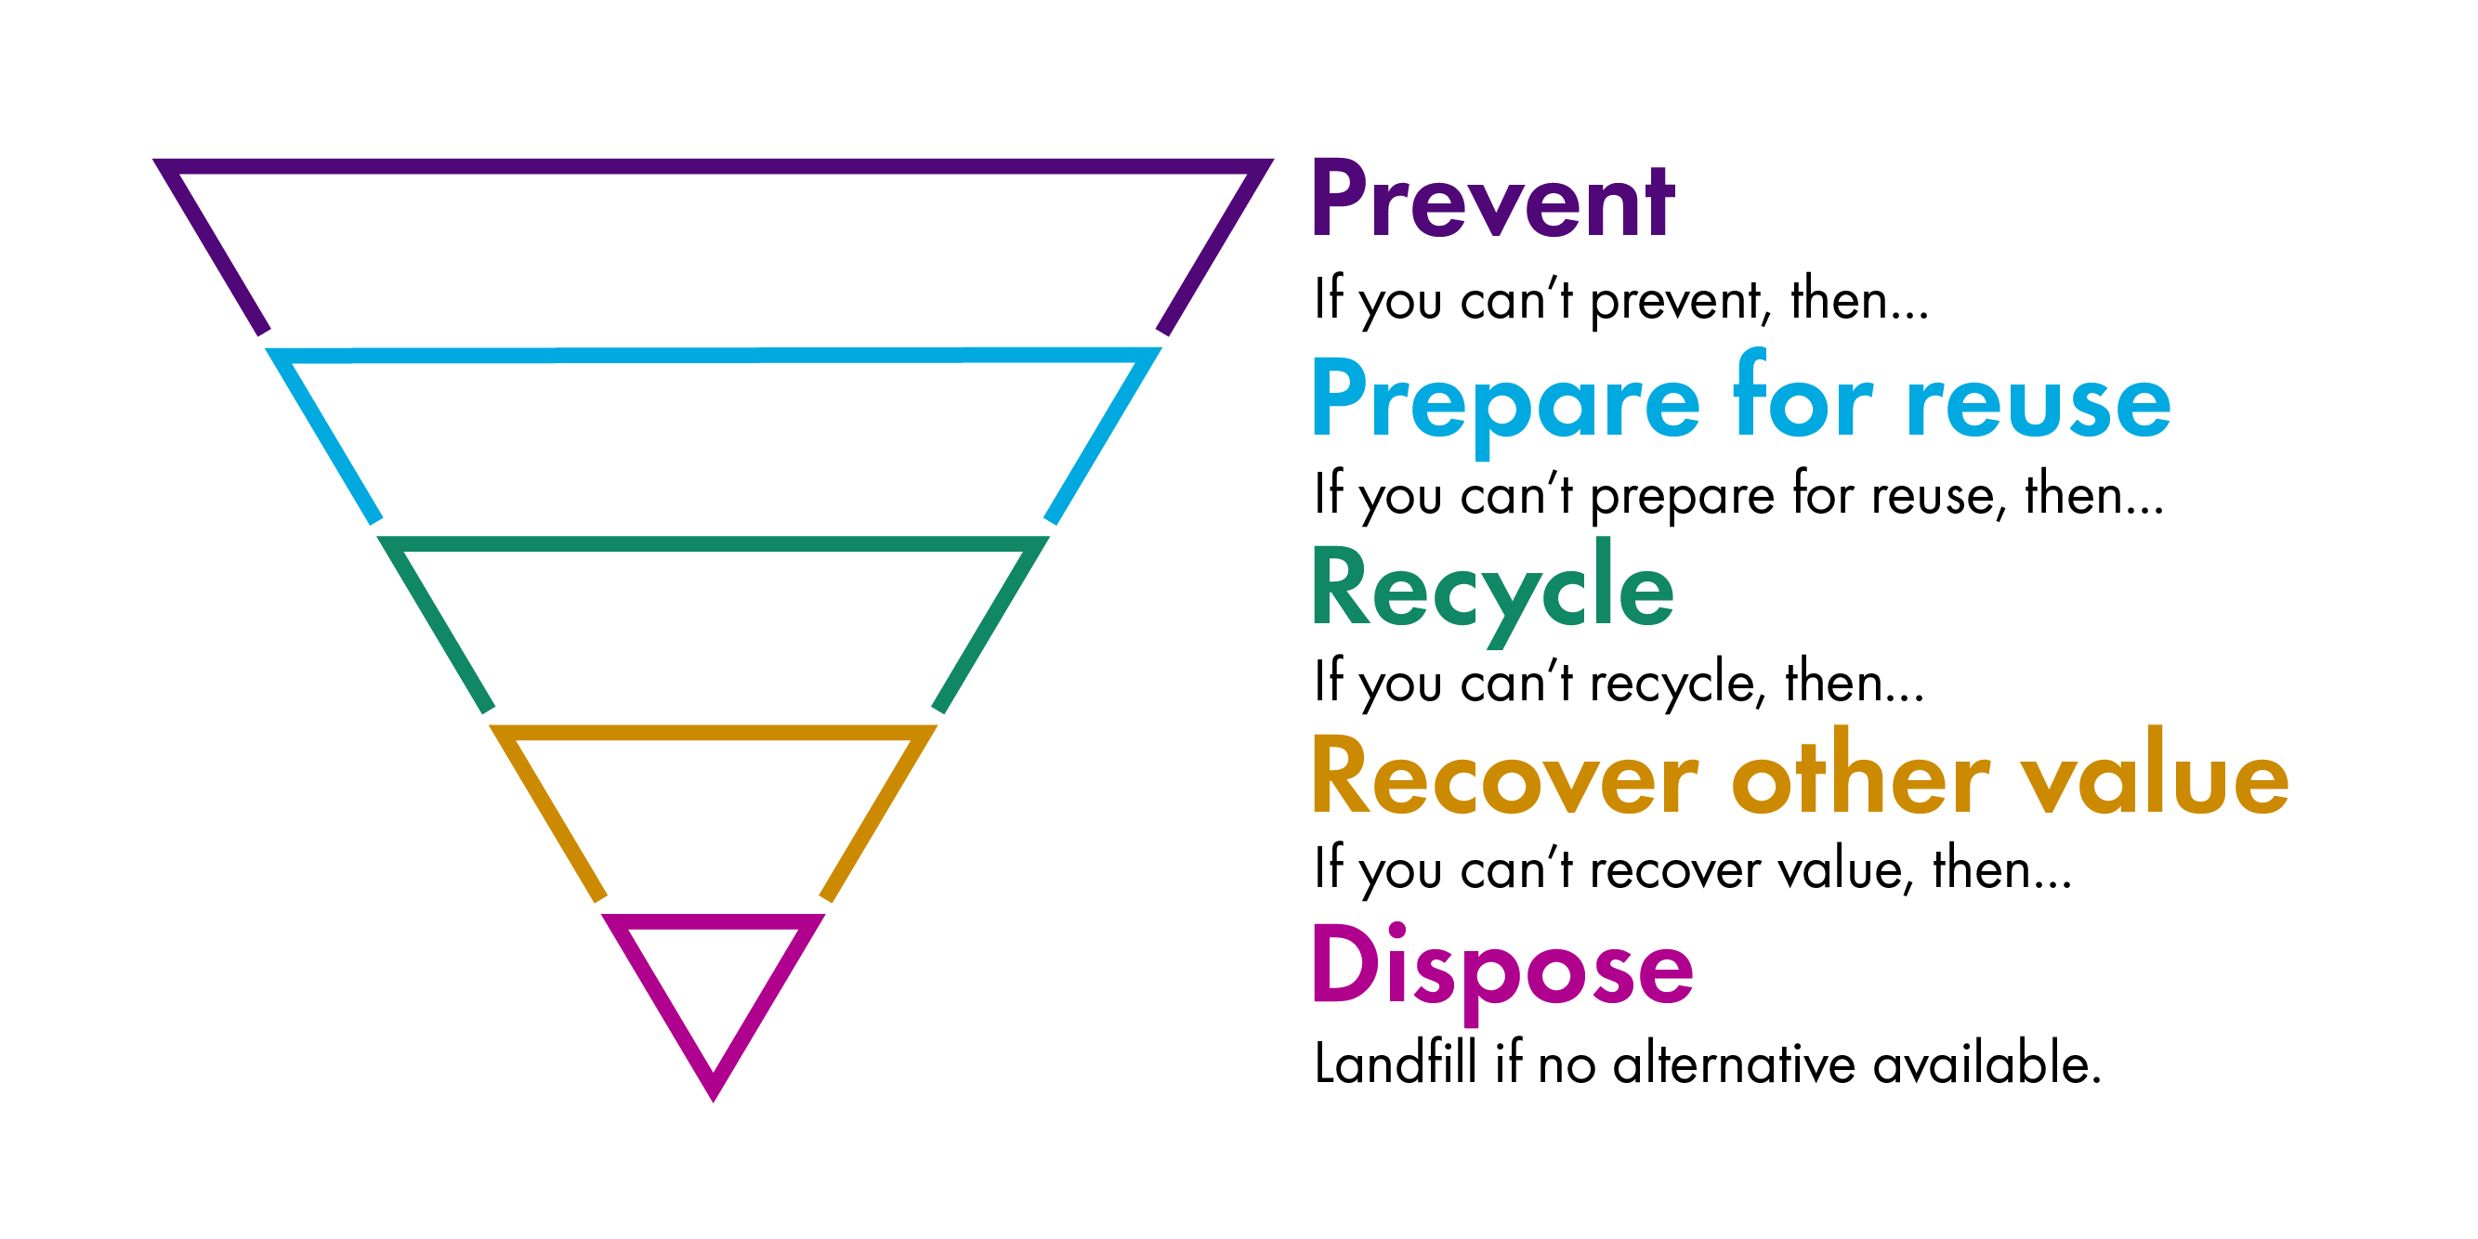Source: Circular Economy (Scotland) Bill | Scottish Parliament, Figure 12., The Scottish Government, 22 September 2023

Appendix 3: South Lanarkshire College’s Circular Economy Journey
A circular economy tackles climate change by reducing carbon impacts across the lifecycle of products, as well as other global challenges like biodiversity loss, waste, and pollution.
The Circular Economy process starts with 'Collection' and links to a cluster of actions surrounding the core activity of 'Use'. The surrounding actions are: 'Make', 'Recycle', 'Reuse', 'Remanufacture' and 'Repair.'. The process ends with a line to 'Waste less'.
